“Smart Complaint DSA Tracker”

A Project Report Submitted in the partial fulfillment of the requirements for the award of the degree of

BACHELOR OF TECHNOLOGY

in

DEPARTMENT OF COMPUTER SCIENCE ENGINEERING

by

SRIRAM :2520030218

CHANDRIKA :2520030047

VEDADITHYA :2520030481

Under the Guidance of

Dr. V.Sireesha
Professor
Department of Computer Science and Engineering





2026-27

DEPARTMENT OF COMPUTER SCIENCE ENGINEERING

Declaration

The Project Report entitled “Smart Complaint DSA Tracker” is a record of Bonafide work of SRIRAM – 2520030218, CHANDRIKA – 2520030047, VEDADITHYA – 2520030481 submitted in partial fulfillment for the award of B. Tech in Computer Science and Engineering. The results embodied in this report have not been copied from any other departments/University/Institute.

SRIRAM – 2520030218
CHANDRIKA – 2520030047
VEDADITHYA – 2520030481

DEPARTMENT OF COMPUTER SCIENCE ENGINEERING

CERTIFICATE

This is to certify that the mini project based report entitled “Smart Complaint DSA Tracker” is a bonafide work done and submitted by SRIRAM – 2520030218, CHANDRIKA – 2520030047, VEDADITHYA – 2520030481 in partial fulfillment of the requirements for the award of the degree of BACHELOR OF TECHNOLOGY in Department of Computer Science Engineering, during the academic year 2026-27.

Signature of the Guide Signature of the HOD
(Dr. V.Sireesha)
ACKNOWLEDGEMENT

We express our sincere gratitude to our project guide, Dr. V. Sireesha, Professor, Department of Computer Science and Engineering, for her constant guidance, valuable suggestions and encouragement throughout the course of this project. Her timely feedback helped us to shape the Smart Complaint DSA Tracker from an initial idea into a complete working system.
We are also thankful to Dr. P. Venkateswara Rao, Associate Professor and Head of the Department of Computer Science and Engineering, for providing the facilities and the academic environment needed to carry out this work. We extend our thanks to all the faculty members of the department for the knowledge of data structures and algorithms that they imparted to us, which forms the foundation of this project.
Finally, we thank our friends and family members for their support and motivation, and the management of Koneru Lakshmaiah Education Foundation for giving us the opportunity to take up this project.

SRIRAM – 2520030218
CHANDRIKA – 2520030047
VEDADITHYA – 2520030481

Abstract

Organisations such as campuses, housing societies and utility providers receive a large number of complaints every day. Traditional ticketing systems usually depend on heavy third-party libraries and black-box relational databases, and they often fail to filter duplicate tickets, to escalate life-threatening hazards immediately, to distribute work fairly among technicians, or to reveal the single systemic fault behind many separate complaints. This project, the Smart Complaint DSA Tracker, shows that these real-world operational workflows can be built from first principles using only fundamental data structures and algorithms, in pure Java with zero external libraries and zero database.

The system is organised as a dual-portal Java Swing application. The Customer Portal supports registration, multi-field ticket submission with a real-time hazard detector, a step-by-step timeline, 1-5 star feedback and an in-app notification centre. The Organization Portal supports role-based Admin/Staff login, an operations dashboard, smart staff dispatch, duplicate detection and merging, a systemic pattern cluster analyzer and live parallel analytics. Seven algorithm engines power these features: Aho-Corasick, KMP and Rabin-Karp for hazard detection; binary max-heap and min-heap for priority and SLA monitoring; Hopcroft-Karp matching and Min-Cost Max-Flow for staff dispatch; Wagner-Fischer Levenshtein distance for duplicate blocking; suffix array with Kasai LCP for root-cause clustering; Graham's LPT, Held-Karp and metric TSP for scheduling and routing; and Fork/Join with Blelloch prefix sum for parallel analytics.

All containers, including nine handcrafted data structures, are built from scratch without the java.util collections. Data is kept in ten human-readable flat files that are written atomically and protected by timestamped backups. The system passed all 13 unit and integration tests, used no external library or database, and meets the six course outcomes of the Advanced DSA curriculum.

Table of Contents

 |  |  | Page No.
 | Acknowledgement
 | Abstract
 | Table of Contents
 | List of Figures
1 | Introduction | 1.1 Overview  1.2 Problem statement  1.3 Scope of the project  1.4 Objectives  1.5 Organization of the report | 1-3
2 | System Requirements | 2.1 Functional Requirements  2.2 Non-Functional Requirements  2.3 Hardware and Software Requirements | 4-5
3 | System Design | 3.1 High-level Architecture Diagram  3.2 Description of each layer | 6-8
4 | Implementation | 4.1 Module-wise implementation  4.2 Front-end logic (UI rendering, state management)  4.3 Data persistence and file handling  4.4 Parallel analytics | 9-12
5 | Results | 5.1 Test summary  5.2 Representative results  5.3 Algorithm complexity summary  5.4 Course outcome compliance | 13-15
6 | Challenges & Limitations | 6.1 Issues faced during development  6.2 Solutions applied  6.3 Limitations of the System | 16
7 | Conclusion & Future Work | 7.1 Conclusion  7.2 Future Work  7.3 Skills learned during development | 17
 | References | - Books, research papers and documentation sites used | 18

List of Figures

1.1 Seven Algorithm Engines of the Smart Complaint DSA Tracker 1
3.1 High-Level Architecture of the Smart Complaint DSA Tracker 6
3.2 Complaint Lifecycle Data Flow 8
5.1 Hazard Detection Result (Auto-tagged CRITICAL) 13
5.2 Operations Dashboard with SLA Priority Queue 13
5.3 Smart Staff Dispatch Results 14
5.4 Duplicate Detection and Merge Results 14
5.5 Root-Cause Cluster Analysis Results 14
5.6 Maintenance Scheduling and Parallel Analytics Results 15

- INTRODUCTION
1.1 Overview
Complaint management is a core activity for every organisation that serves many people: a college campus receives maintenance requests, a housing society receives plumbing and electrical issues, and a utility provider receives outage reports. A good complaint system must accept tickets quickly, recognise urgent hazards, remove duplicates, assign each ticket to a suitable technician and, finally, help the organisation understand why the complaints are happening.
The Smart Complaint DSA Tracker is an enterprise-style complaint lifecycle system engineered entirely with custom data structures and algorithms. It is written in pure Java 21, uses zero external libraries and zero database, and keeps all its data in human-readable text files. Every real-world feature of the system is powered by a specific class of algorithm, as shown in Fig. 1.1: hazard detection by string-matching automata, priority and SLA tracking by binary heaps, staff dispatch by graph matching and network flow, duplicate blocking by dynamic programming, root-cause clustering by suffix arrays, scheduling and routing by approximation and exact algorithms, and analytics by parallel computing.
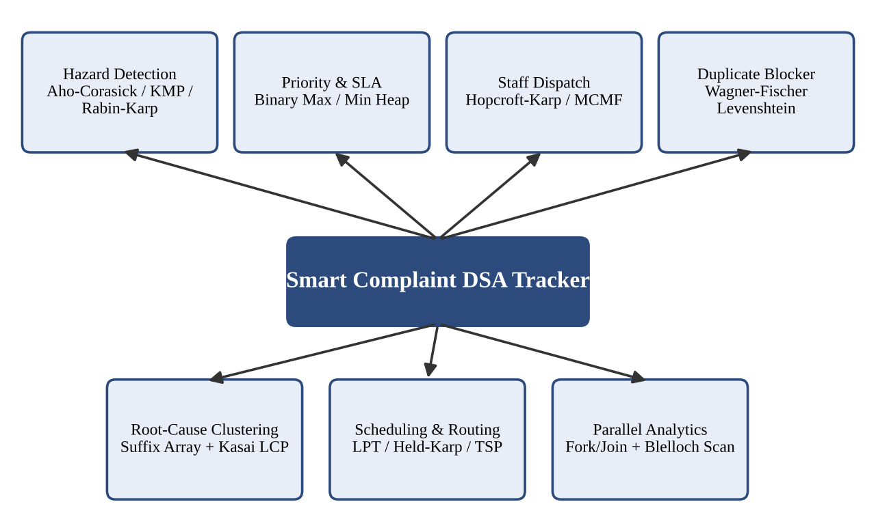
Fig. 1.1 Seven Algorithm Engines of the Smart Complaint DSA Tracker
The application follows a dual-portal architecture built with Java Swing and AWT and a custom dark design system. A Main Portal Launcher opens either the Customer Portal, where citizens submit and track complaints, or the Organization Portal, where administrators and staff manage, dispatch and analyse them.
1.2 Problem Statement
Traditional enterprise ticketing systems lean on heavy third-party dependencies and black-box relational databases. Even then, they leave several operational problems unsolved, which this project addresses:
- Spam and duplicate tickets: the same fault is reported many times in different words, which overwhelms departments and wastes effort.
- Real-time threat triage: complaints describing fire, sparks, gas leaks or explosions must be escalated instantly instead of waiting in a first-come-first-served queue.
- Fair workload dispatch: complaints must be assigned to technicians according to their skills and capacity, while keeping cost and travel distance low.
- Root-cause clustering: dozens of separate tickets may all be symptoms of one systemic infrastructure failure, which a single complaint never reveals.
- Maintenance planning: tasks must be scheduled across technicians and inspection routes must be planned, even though the exact problems are NP-hard.
1.3 Scope of the Project
The scope of the project covers the complete life cycle of a complaint, from submission to resolution and feedback:
- Customer Portal: login and registration, multi-field ticket submission, real-time hazard detector, step-by-step graphical timeline, 1-5 star feedback and rating, and an in-app notification centre.
- Organization Portal: role-based login (Admin / Staff), operations dashboard with KPI cards, smart staff dispatch dock, duplicate detection and merging, systemic pattern cluster analyzer and live parallel analytics.
- Algorithm engines: seven engines for hazard detection, priority and SLA, dispatch, duplicate blocking, clustering, scheduling and routing, and parallel analytics.
- Data layer: nine handcrafted data structures and a zero-database flat-file persistence layer with atomic writes, delimiter escaping and automated snapshots.
The system is a self-contained desktop application. It is not connected to any external service, and it uses sample data created for testing.
1.4 Objectives
- To prove that a high-performance complaint management system can be engineered using only fundamental data structures and algorithms, without external libraries or a database.
- To detect hazardous complaints in real time and escalate their priority automatically.
- To rank complaints by urgency and track SLA breach timers so that the most urgent work always surfaces first.
- To assign complaints to technicians fairly, respecting skill and workload capacity, while minimising cost and distance.
- To identify near-duplicate complaints and recurring phrase patterns that point to a common root cause.
- To schedule maintenance tasks and plan inspection routes using exact methods for small inputs and approximation algorithms for large inputs.
- To store data safely in flat files that cannot be corrupted by sudden termination, and to verify every engine by tests.
1.5 Organization of the Report
Chapter 2 lists the functional and non-functional requirements. Chapter 3 presents the architecture and the role of each layer. Chapter 4 explains the implementation of each algorithm engine, the data structures, the user interface and the persistence layer. Chapter 5 presents the results and test summary. Chapter 6 discusses the challenges and limitations, and Chapter 7 gives the conclusion and future work.
- SYSTEM REQUIREMENTS
2.1 Functional Requirements
The functional requirements of the system are summarised in Table 2.1.
Table 2.1 Functional Requirements
ID | Requirement | Module / Engine
FR1 | Customer registration and login; role-based Admin / Staff login | Both portals
FR2 | Multi-field complaint submission with live hazard detection while typing | Customer Portal, Aho-Corasick
FR3 | Automatic category tagging and escalation to CRITICAL priority for hazard keywords | Section A
FR4 | Dynamic priority ranking and Earliest-Deadline-First SLA monitoring | Section B (heaps)
FR5 | Assignment of complaints to staff by department skill and workload capacity | Section C (matching, MCMF)
FR6 | Detection of near-duplicate complaints and one-click merging with combined history | Section D (Levenshtein)
FR7 | Discovery of recurring phrases across tickets to find systemic root causes | Section E (suffix array)
FR8 | Maintenance task scheduling and technician inspection routing | Section F (LPT, Held-Karp, TSP)
FR9 | Step-by-step timeline, notifications, and 1-5 star feedback | Customer Portal
FR10 | Operations dashboard with KPI cards and live parallel analytics | Organization Portal
FR11 | Persistent storage with backup and restore | Flat-file layer, BackupManager

2.2 Non-Functional Requirements
- Correctness: every algorithm engine is verified by unit and integration tests (13 of 13 tests passed).
- Performance: hazard detection finishes in under a millisecond per complaint, and the algorithms are chosen for their time complexity.
- Reliability and data safety: writes are atomic and point-in-time backups can be restored with one click, so a sudden termination does not corrupt data.
- Independence: zero external libraries and zero database; the project depends only on the Java platform.
- Maintainability: each engine is a separate class, and the nine data structures are reusable generic containers.
- Usability: a consistent dark design system (AppTheme.java) and role-specific portals for customers and organisation staff.
- Portability: the project can be cloned and run on any system with Java 17/21.
2.3 Hardware and Software Requirements
Table 2.2 Environment
Item | Requirement
Programming language | Java (pure Java 21; runs on Java 17/21)
User interface | Java Swing and AWT (custom theme AppTheme.java)
Storage | Plain-text flat files under project/data/ (no database)
External libraries | None
Run command | java -cp bin Main (PowerShell) or run.bat (CMD)
Operating system | Any operating system with a Java runtime (Windows, Linux, macOS)
Hardware | A standard desktop or laptop; multi-core processor recommended for the parallel analytics

- SYSTEM DESIGN
3.1 High-level Architecture Diagram
The high-level architecture of the Smart Complaint DSA Tracker is shown in Fig. 3.1. A Main Portal Launcher opens the Customer Portal or the Organization Portal. Both portals use the same algorithm engine layer, which in turn is built on the handcrafted data structures and stores its data in flat files.
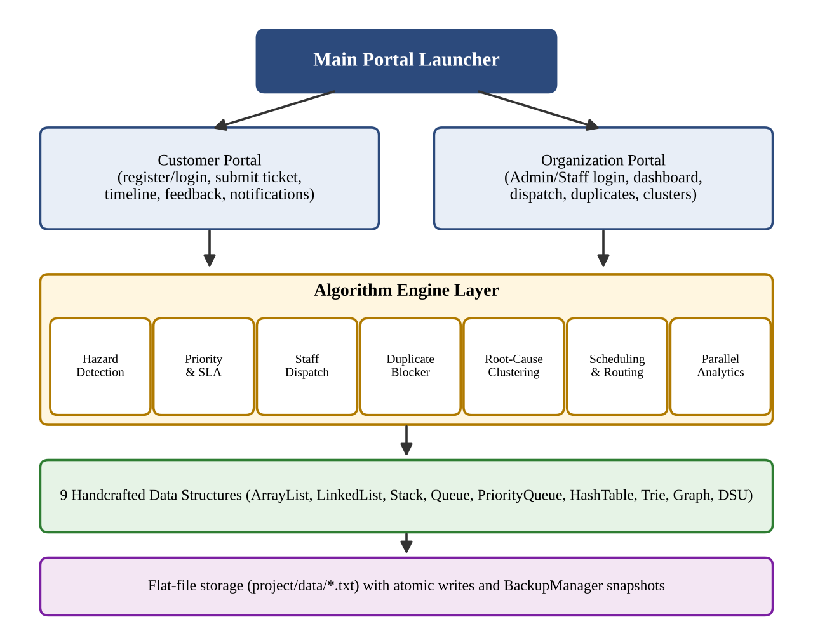
Fig. 3.1 High-Level Architecture of the Smart Complaint DSA Tracker
3.2 Description of Each Layer
3.2.1 Presentation Layer
The presentation layer is written with Java Swing and AWT and uses a custom dark design system (AppTheme.java). The Customer Portal offers login and registration, multi-field ticket submission, a real-time hazard detector, a graphical timeline, feedback and notifications. The Organization Portal offers role-based login, an operations dashboard with KPI cards, a smart staff dispatch dock, duplicate detection and merging, a systemic pattern cluster analyzer and live parallel analytics.
3.2.2 Algorithm Engine Layer
This layer contains the seven algorithm engines. Each engine solves one class of problem, and the mapping from feature to algorithm is given in Table 3.1.
Table 3.1 Mapping of Features to Algorithm Engines
Section | Feature | Algorithms | Complexity
A | Hazard detection and search | Aho-Corasick, KMP / Z-algorithm, Rabin-Karp | O(N+M+Z), O(N+M)
B | Priority triage and SLA monitoring | Binary max-heap, binary min-heap (EDF) | O(log N) per operation
C | Staff dispatch and workload balance | Hopcroft-Karp, Min-Cost Max-Flow (SPFA) | O(E√V)
D | Duplicate blocker and suggestions | Wagner-Fischer Levenshtein distance | O(N × M)
E | Root-cause clustering | Suffix array with Kasai LCP | O(N log²N) build, O(N) query
F | Scheduling and maintenance planning | Graham's LPT, Held-Karp, metric TSP | O(N log N), O(2ᴺN²), MST doubling
- | Parallel analytics | Fork/Join tree reduction, Blelloch prefix sum | Work O(N), span O(log N)

3.2.3 Data Structure Layer
No java.util collection is used. Nine generic containers are built from scratch: CustomArrayList, CustomLinkedList, CustomStack, CustomQueue, CustomPriorityQueue, CustomHashTable, CustomTrie, CustomGraph and CustomDisjointSetUnion. The algorithm engines are written on top of these containers.
3.2.4 Persistence Layer
All data lives in ten human-readable flat files under project/data/: complaints, customers, staff, departments, history, responses, assignments, feedback, notifications and users. Every write is committed to a temporary *.txt.tmp file and then atomically renamed. A BackupManager takes timestamped point-in-time backups with one-click restore.
3.2.5 Data Flow
Fig. 3.2 shows how a complaint moves through the system. When a customer submits a ticket, the hazard scan checks the text, the duplicate check compares it with existing tickets, and the priority and SLA heaps rank it. The dispatch engine then assigns it to a suitable technician. When the staff member resolves it, the history is updated, a notification is sent and the customer can give feedback. The stored tickets are also used by the clustering and analytics engines.
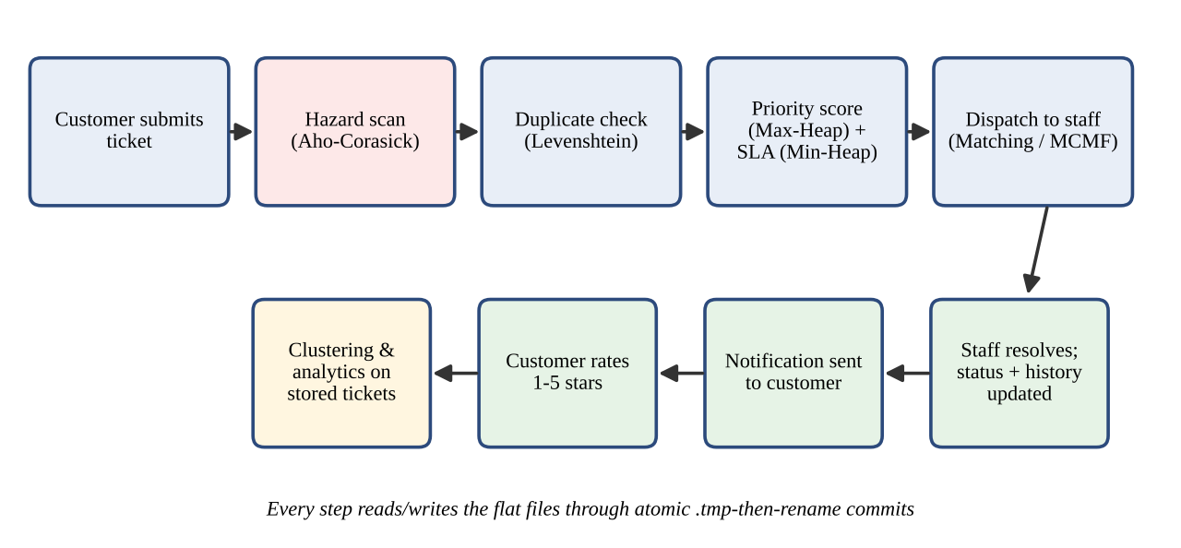
Fig. 3.2 Complaint Lifecycle Data Flow
- IMPLEMENTATION
4.1 Module-wise Implementation
This section explains each algorithm engine with its pseudocode and the way it is used in the system.
4.1.1 Section A: Hazard Detection and Search
The Aho-Corasick automaton is a multi-keyword dictionary trie with failure links. All hazard keywords such as "fire", "spark", "gas leak" and "explosion" are inserted into the trie, the failure links are built with a breadth-first traversal, and the complaint text is scanned in a single pass in O(N+M+Z) time, where N is the text length, M the total keyword length and Z the number of matches. When a keyword is found, the system tags the category automatically and raises the priority to CRITICAL.
AhoCorasickSearch(text, keywords):
build trie from keywords
build failure links using BFS from the root
state = root
for each character c in text:
while state has no child c and state != root:
state = failure(state)
if state has child c: state = child(state, c)
for each keyword ending at state or its failure chain:
report match
KMP and the Z-algorithm provide linear-time exact search, O(N+M), inside complaint descriptions without backtracking. Rabin-Karp uses a polynomial rolling hash and is applied to long text logs (patterns longer than 15 characters), with O(N+M) average time.
KMP(text, pattern):
lps = prefix-function(pattern)
i = 0, j = 0
while i < len(text):
if text[i] == pattern[j]: i++, j++
if j == len(pattern): report match at i - j; j = lps[j-1]
else if i < len(text) and text[i] != pattern[j]:
if j > 0: j = lps[j-1] else: i++
4.1.2 Section B: Priority Triage and SLA Monitoring
Two binary heaps, both implemented by CustomPriorityQueue, keep every dashboard sorted by urgency. The binary max-heap ranks the complaints dynamically using the urgency score:
Score = (Priority x 25) + (Affected x 0.8) + Overdue Boost
so the complaint with the highest urgency is always at the top. The binary min-heap implements Earliest Deadline First (EDF) dispatch: it tracks the SLA breach timers and pushes the complaint that is closest to breaching its SLA to the top of the technician dashboard. Insertion and removal take O(log N) time and reading the top element takes O(1) time.
Insert(heap, ticket): append ticket; sift-up while parent is worse
ExtractTop(heap): swap root with last; remove last; sift-down root
Triage: max-heap ordered by Score SLA: min-heap ordered by deadline
4.1.3 Section C: Staff Dispatch and Workload Balance
Dispatch is modelled as a graph problem. Hopcroft-Karp finds a maximum bipartite matching between unassigned complaints and eligible technicians, where an edge exists when the technician's department skill fits the complaint, and the per-technician workload capacity is enforced. It runs in O(E√V) time. Min-Cost Max-Flow, solved with Successive Shortest Path using SPFA, then minimises the resolution cost and travel distance while maximising the total number of resolved complaints. This turns dispatch into a network-flow optimisation instead of a first-come-first-served queue.
HopcroftKarp(complaints, technicians):
repeat:
BFS from free complaints to build level graph
DFS along level graph to find vertex-disjoint augmenting paths
augment matching along each path
until no augmenting path exists
MCMF(source, sink):
while SPFA finds shortest-cost path source -> sink with spare capacity:
push bottleneck flow along the path; add cost x flow
4.1.4 Section D: Fuzzy Matching and Duplicate Blocker
The Wagner-Fischer algorithm fills an edit-distance matrix with dynamic programming in O(N × M) time. It is used to identify near-identical complaints submitted by different users, so that the administrator can merge the duplicates with one click into a single record with combined history. The same edit distance powers the "Did you mean?" search suggestions. For example, "Water leakage near main gate 2" and "Leak of water close to gate no.2" are flagged as an 87% match.
EditDistance(a, b):
D[i][0] = i, D[0][j] = j
for i in 1..len(a): for j in 1..len(b):
cost = 0 if a[i] == b[j] else 1
D[i][j] = min(D[i-1][j] + 1, D[i][j-1] + 1, D[i-1][j-1] + cost)
similarity = 1 - D[len(a)][len(b)] / max(len(a), len(b))
4.1.5 Section E: Root-Cause Incident Clustering
The suffix array indexes all complaint text, and Kasai's algorithm builds the Longest Common Prefix (LCP) array in linear time. Long LCP values show phrases that repeat across many tickets, so the system can discover systemic infrastructure faults that a single complaint would never reveal. The suffix array is built in O(N log²N) time and queried in O(N) time. For example, 20 separate tickets that all contain the phrase "transformer exploded near block B" are grouped into one root cause.
BuildSuffixArray(S): sort suffixes by prefix doubling (rank by 1, 2, 4, ... characters)
Kasai(S, SA): rank = inverse of SA; h = 0
for i in 0..n-1: if rank[i] > 0: j = SA[rank[i]-1]
while S[i+h] == S[j+h]: h++
LCP[rank[i]] = h; if h > 0: h--
Cluster: scan LCP; groups of adjacent suffixes with LCP >= threshold -> recurring phrase
4.1.6 Section F: Optimal Task Scheduling and Maintenance Planning
Three algorithms trade exactness for speed as the problem grows. Graham's Longest Processing Time (LPT) rule solves the NP-hard makespan problem approximately: tasks are ordered by length and assigned greedily to the least-loaded technician, giving a 4/3-approximation (rho <= 4/3) in O(N log N) time. Held-Karp bitmask dynamic programming finds the exact best sequential inspection route for small sets of critical tasks (N <= 12) in O(2ᴺN²) time. For large areas, metric TSP uses minimum-spanning-tree doubling and shortcutting under the triangle inequality, a 2-approximation, for technician field-inspection routing.
LPT(tasks, k): sort tasks by length descending
for each task: assign to technician with the smallest current load
HeldKarp(dist, n): dp[mask][last] = shortest route visiting 'mask' ending at 'last'
dp[{0}][0] = 0
for mask, last: for next not in mask:
dp[mask | next][next] = min(dp[mask][last] + dist[last][next])
4.1.7 Handcrafted Data Structures
Table 4.1 Handcrafted Data Structures
No. | Data structure | Role in the system
1 | CustomArrayList<T> | Dynamic array, amortised O(1) append, 1.5x growth
2 | CustomLinkedList<T> | Doubly linked list, O(1) head/tail, chronological history
3 | CustomStack<T> | LIFO stack for audit trails and action rollbacks
4 | CustomQueue<T> | FIFO queue for ticket triage and BFS traversal
5 | CustomPriorityQueue<T> | Binary heap in both Min (EDF) and Max (triage) modes
6 | CustomHashTable<K,V> | Separate chaining with resizing, O(1) ticket lookups
7 | CustomTrie | Prefix tree for live keyword autocompletion
8 | CustomGraph<V> | Adjacency list for BFS, DFS, Dijkstra and clustering
9 | CustomDisjointSetUnion<T> | Path compression and union-by-rank for Kruskal's MST

4.2 Front-end Logic (UI Rendering, State Management)
The user interface is written with Java Swing and AWT. A Main Portal Launcher starts the application and opens either the Customer Portal or the Organization Portal. All screens use one custom dark design system, AppTheme.java, so that colours, fonts and components are consistent.
The interface is event-driven. While the customer types a complaint, the real-time hazard detector runs the Aho-Corasick engine on the text and shows the detected hazard and priority immediately. In the Organization Portal, the dashboard builds its KPI cards and ranked lists from the heaps and from the analytics engine, the dispatch dock calls the matching and flow engines, and the duplicate and cluster screens call the Levenshtein and suffix-array engines. The application state is held in memory in the custom data structures and is written back to the flat files after every change.
4.3 Data Persistence and File Handling (No External API)
The project deliberately has no external API and no database. All data is stored in ten human-readable text files under project/data/. Three techniques make this storage safe:
- Atomic writes: each file is first written to a *.txt.tmp file and then renamed, so a sudden termination cannot leave a half-written file.
- Delimiter escaping: tab and newline characters inside a field are stored as \t and \n, so multi-line complaint text does not break the record format.
- Automated snapshots: BackupManager creates timestamped point-in-time backups and supports one-click restore.
4.4 Parallel Analytics
The dashboards use multiple cores through a ForkJoinPool. A parallel tree reduction (work O(N), span O(log N)) calculates the average, minimum and maximum resolution time across cores. The Blelloch prefix sum, a two-pass scan, produces the cumulative daily ticket trend in real time.
ParallelReduce(array, lo, hi):
if hi - lo <= THRESHOLD: return sequential result
fork ParallelReduce(left half); compute right half; join
return combine(left, right)
- RESULTS
5.1 Test Summary
Every engine is tested and benchmarked against the course outcomes. The test results are summarised in Table 5.1.
Table 5.1 Test Summary
Measure | Result
Unit and integration tests passed | 13 / 13
Success rate across restart cycles | 100%
External libraries or databases used | 0
Course outcomes met (CO1 to CO6) | 6 / 6

5.2 Representative Results
Hazard detection: the complaint "Smoke and a burning smell near the transformer, possible fire risk" is auto-tagged with priority CRITICAL in under 1 ms (Fig. 5.1).
[ Insert screenshot of the Customer Portal hazard detector ]
Fig. 5.1 Hazard Detection Result (Auto-tagged CRITICAL)
Priority and SLA: the technician dashboard lists the complaints in the order of the SLA timers, for example Ticket #2291 with 4 min to SLA breach, Ticket #2287 with 22 min, and Ticket #2299 with 1 hr 05 min, so the highest urgency always surfaces first (Fig. 5.2).
[ Insert screenshot of the Organization Portal dashboard ]
Fig. 5.2 Operations Dashboard with SLA Priority Queue
Staff dispatch: tickets are matched to technicians by skill and capacity, with minimised cost and distance and maximised throughput (Fig. 5.3).
[ Insert screenshot of the dispatch dock ]
Fig. 5.3 Smart Staff Dispatch Results
Duplicate detection: Ticket #401 "Water leakage near main gate 2" and Ticket #407 "Leak of water close to gate no.2" are detected as an 87% match and flagged for admin review. One click merges both into a single record with combined history (Fig. 5.4).
[ Insert screenshot of the duplicate review screen ]
Fig. 5.4 Duplicate Detection and Merge Results
Root-cause clustering: 20 separate tickets are traced to one recurring phrase, "transformer exploded near block B", which is reported as one root cause (Fig. 5.5).
[ Insert screenshot of the pattern cluster analyzer ]
Fig. 5.5 Root-Cause Cluster Analysis Results
Scheduling and analytics: the maintenance schedule, inspection route and the live parallel analytics are shown in Fig. 5.6.
[ Insert screenshot of the scheduling and analytics screens ]
Fig. 5.6 Maintenance Scheduling and Parallel Analytics Results
5.3 Algorithm Complexity Summary
Table 5.2 Time Complexity of the Algorithms Used
Algorithm | Purpose | Complexity
Aho-Corasick | Multi-keyword hazard search | O(N+M+Z)
KMP / Z-algorithm | Exact search | O(N+M)
Rabin-Karp | Search in long text logs | O(N+M) average
Binary heap | Priority and SLA queues | O(log N) per operation
Hopcroft-Karp | Technician matching | O(E√V)
Wagner-Fischer | Duplicate detection | O(N × M)
Suffix array + Kasai LCP | Root-cause clustering | O(N log²N) build, O(N) query
Graham's LPT | Makespan scheduling | O(N log N), 4/3-approximation
Held-Karp | Exact inspection route (N <= 12) | O(2ᴺN²)
Metric TSP (MST doubling) | Large-area routing | 2-approximation
Fork/Join reduction | Parallel statistics | Work O(N), span O(log N)

5.4 Course Outcome Compliance
The project meets all requirements of the Advanced DSA curriculum. The six outcome areas covered are problem strategy classification, string algorithms, dynamic programming, network flow, approximation and NP theory, and randomised and parallel computing.
- CHALLENGES AND LIMITATIONS
6.1 Issues Faced during Development
- Building without libraries: because no java.util collection could be used, every container had to be designed, implemented and tested before the algorithms could be written.
- Data safety with plain files: without a database, a sudden termination during a write could corrupt a file, and multi-line complaint text could break the record format.
- NP-hard planning problems: task scheduling and inspection routing cannot be solved exactly for large inputs in reasonable time.
- Responsiveness: dashboards over many tickets needed to stay fast, and hazard detection had to run while the user types.
- Ranking and matching: urgency, skill and capacity had to be combined fairly into a single ordering and an assignment.
6.2 Solutions Applied
- Nine reusable generic data structures were handcrafted first and then reused by every engine.
- Atomic *.txt.tmp-then-rename writes, delimiter escaping and BackupManager snapshots protect the files.
- Exact Held-Karp is used only for small sets (N <= 12), while the 4/3-approximation LPT and the 2-approximation MST-doubling TSP handle large inputs.
- Linear-time string matching (Aho-Corasick, KMP), heaps and a parallel Fork/Join analytics engine keep the system responsive.
- The urgency score formula and the matching plus min-cost flow combination give a clear, tunable ranking and fair assignment.
6.3 Limitations of the System
- Flat text files are used instead of a database, so very large volumes of tickets and concurrent multi-user access are limited.
- It is a desktop Swing application and has no web or mobile interface.
- The scheduling and routing results for large inputs are approximate, not optimal.
- The system has not been connected to real notification channels such as email or SMS, and it works on sample data.
- CONCLUSION AND FUTURE WORK
7.1 Conclusion
The Smart Complaint DSA Tracker shows that a complete complaint lifecycle system can be engineered from first principles using fundamental computer science concepts. Seven algorithm engines and nine handcrafted data structures handle hazard detection, priority and SLA tracking, fair dispatch, duplicate blocking, root-cause clustering, scheduling and parallel analytics, with no external library and no database. All 13 tests passed, and the project meets all six course outcomes. The project connects the theory of string algorithms, heaps, graph algorithms, dynamic programming, approximation algorithms and parallel computing with a practical and useful application.
7.2 Future Work
- Replace the flat files with a database backend for large-scale and multi-user use.
- Add a web and mobile interface for customers and technicians.
- Add stronger authentication and email or SMS notifications.
- Add richer analytics and predictive models for complaint trends.
- Benchmark the engines on much larger datasets and on more cores.
7.3 Skills Learned during Development
- Designing and implementing generic data structures from scratch in Java.
- Applying string algorithms, dynamic programming, graph matching and network flow to a real problem.
- Understanding approximation algorithms and NP-hard problems, and choosing exact or approximate methods by input size.
- Parallel programming with Fork/Join and prefix-sum scans.
- Building event-driven Swing interfaces, writing tests and working as a team.
REFERENCES
- T. H. Cormen, C. E. Leiserson, R. L. Rivest and C. Stein, Introduction to Algorithms, 3rd ed. Cambridge, MA, USA: MIT Press, 2009.
- A. V. Aho and M. J. Corasick, “Efficient string matching: An aid to bibliographic search,” Communications of the ACM, vol. 18, no. 6, pp. 333–340, 1975.
- D. E. Knuth, J. H. Morris and V. R. Pratt, “Fast pattern matching in strings,” SIAM Journal on Computing, vol. 6, no. 2, pp. 323–350, 1977.
- R. M. Karp and M. O. Rabin, “Efficient randomized pattern-matching algorithms,” IBM Journal of Research and Development, vol. 31, no. 2, pp. 249–260, 1987.
- R. A. Wagner and M. J. Fischer, “The string-to-string correction problem,” Journal of the ACM, vol. 21, no. 1, pp. 168–173, 1974.
- J. E. Hopcroft and R. M. Karp, “An n^(5/2) algorithm for maximum matchings in bipartite graphs,” SIAM Journal on Computing, vol. 2, no. 4, pp. 225–231, 1973.
- M. Held and R. M. Karp, “A dynamic programming approach to sequencing problems,” Journal of the Society for Industrial and Applied Mathematics, vol. 10, no. 1, pp. 196–210, 1962.
- R. L. Graham, “Bounds on multiprocessing timing anomalies,” SIAM Journal on Applied Mathematics, vol. 17, no. 2, pp. 416–429, 1969.
- T. Kasai, G. Lee, H. Arimura, S. Arikawa and K. Park, “Linear-time longest-common-prefix computation in suffix arrays and its applications,” in Proc. CPM 2001, LNCS vol. 2089, pp. 181–192, 2001.
- U. Manber and G. Myers, “Suffix arrays: A new method for on-line string searches,” SIAM Journal on Computing, vol. 22, no. 5, pp. 935–948, 1993.
- G. E. Blelloch, “Prefix sums and their applications,” Technical Report CMU-CS-90-190, Carnegie Mellon University, 1990.
- Oracle, “Java Platform, Standard Edition Documentation” (Swing, AWT and java.util.concurrent Fork/Join framework). [Online]. Available: https://docs.oracle.com/en/java/

